Math Operation

Adds Value on Either Subtract right hand Multiplies values
Side of Operator. Operator from left hand on either side of
a + b = 30 Operator. a – b = -10 operator.
a * b = 200

Divides Left hand operator from right hand operator
b/a = 2

popular_number = 4
popular_number = 4 + 4
- The Variable popular_number holds value 4
- Add another integer 4 and assign the answer to same variable.
- “+” is plus variable.
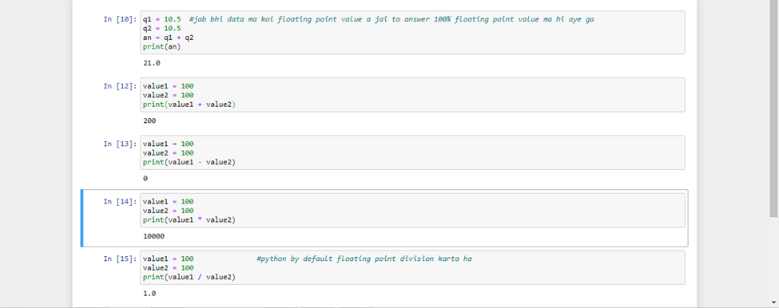
Double // ka sath Answer integer ma ata ha.
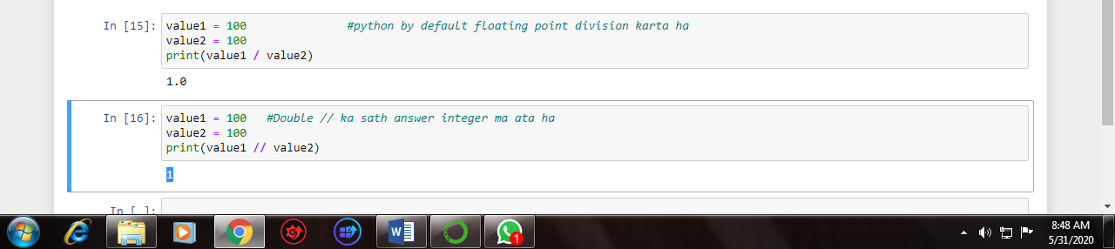
In string + is not addition but it is Concatenation (Joined).
